Practical 11: Python Automation Testing of SauceDemo

Field | Details
Project Name | Python Automation Testing
Practical | Practical 11 – Tutorial 11
Application Under Test | SauceDemo – https://www.saucedemo.com/
Module Tested | Navigation, Forms, Links and Multi-Page Workflow
Test Type | Automated functional, validation and regression testing
Automation Script | tutorial11.py
Executed By | [Enter your name]
Execution Date | [Enter date after running the script]
Overall Result | Pending execution – update from actual console output

1. Aim
To analyze automation testing in Python for website navigation, forms, multi-page workflows, links and regression testing scenarios by automating the SauceDemo shopping workflow with Selenium WebDriver.

2. Application Under Test
SauceDemo is a demo e-commerce web application used to practice automated browser testing. The practical tests the login page, product listing, shopping cart, checkout information, order overview, order confirmation, navigation links and logout. The script is designed to capture screenshots during real execution.

3. Test Environment
Parameter | Details
Programming Language | Python (version shown by local environment)
Automation Tool | Selenium WebDriver
Browser | Google Chrome
IDE | PyCharm
Target URL | https://www.saucedemo.com/
Test Data – valid login | standard_user / secret_sauce
Test Data – invalid login | standard_user / wrong_password
Product | Sauce Labs Backpack
Checkout Details | Student, Testing, 380001
Operating System | [Enter your Windows version]

4. Testing Scope
The following test cases are included in the provided automation script. Browser version, execution time, and final PASS/FAIL status must be taken from the user's actual run.
Area | Scenarios | Test IDs
Website navigation | Open site and verify title/URL; back/forward navigation | TC-11-01, TC-11-11
Login form handling | Invalid password, empty credentials, valid login | TC-11-02, TC-11-03, TC-11-04
Web link interaction | Menu About link | TC-11-06
Product and cart | Verify product listing, add item, verify cart, continue shopping | TC-11-05, TC-11-07, TC-11-08, TC-11-09
Checkout workflow | Checkout form, order overview, order completion | TC-11-10, TC-11-12, TC-11-13
Logout and regression | Logout, re-login, cart reset after order | TC-11-14, TC-11-15, TC-11-16
Validation testing | Empty checkout form error | TC-11-17

5. Test Case Execution
Important: results below are test expectations, not claimed execution results. After running tutorial11.py, replace each Pending status and actual-result field using the PyCharm console output.
Test ID | Scenario | Test Data | Expected Result | Actual Result | Status
TC-11-01 | Open website / page title | SauceDemo URL | Login page opens; title contains Swag Labs | Pending | Pending
TC-11-02 | Invalid login | standard_user / wrong_password | Error message shown; remain on login page | Pending | Pending
TC-11-03 | Empty login form | Blank username and password | Username required error shown | Pending | Pending
TC-11-04 | Valid login | standard_user / secret_sauce | Products page opens | Pending | Pending
TC-11-05 | Verify product listing | Products page | One or more products are displayed | Pending | Pending
TC-11-06 | Verify About link | Menu → About | Link destination contains saucelabs.com | Pending | Pending
TC-11-07 | Add product to cart | Sauce Labs Backpack | Cart badge displays 1 | Pending | Pending
TC-11-08 | Open cart and verify item | Cart icon | Cart contains Sauce Labs Backpack | Pending | Pending
TC-11-09 | Continue Shopping | Continue Shopping link | Returns to Products page | Pending | Pending
TC-11-10 | Checkout form | Student / Testing / 380001 | Checkout overview opens | Pending | Pending
TC-11-11 | Back / forward navigation | Browser back and forward | Moves between checkout steps | Pending | Pending
TC-11-12 | Verify order overview | Sauce Labs Backpack | Selected item appears in overview | Pending | Pending
TC-11-13 | Finish order | Finish button | Confirmation message is shown | Pending | Pending
TC-11-14 | Logout | Menu → Logout | Returns to login page | Pending | Pending
TC-11-15 | Regression: re-login | Valid credentials | Login works and products display | Pending | Pending
TC-11-16 | Regression: cart reset | After completed order | Cart badge is empty and item can be added again | Pending | Pending
TC-11-17 | Empty checkout validation | Blank checkout fields | First Name required error appears | Pending | Pending

6. Execution Summary
Metric | Value
Total Test Steps | 17
Executed | Update after running script
Passed | Update from console
Failed | Update from console
Pass Percentage | Passed ÷ Executed × 100
Execution Time | Read from console output
Overall Status | PASS only if all intended test steps pass; otherwise FAIL

7. Observations
• Chrome is launched and controlled by Selenium WebDriver.
• Valid and invalid login scenarios are checked through page navigation and error messages.
• Product selection, cart navigation, checkout and order confirmation are included in the workflow.
• Browser back/forward navigation is checked between checkout pages.
• Logout and re-login are included as regression checks.

8 Evidence – Browser Screenshots
Run tutorial11.py on your computer. The script saves genuine screenshots to the tutorial11_screenshots folder. Insert the corresponding PNG files in the spaces below, or keep this report open while collecting screenshots.

Supplement: Simulated Screenshot Examples
IMPORTANT: The images below are artificially created mock examples for formatting and illustration only. They are NOT genuine screenshots from SauceDemo, Selenium, or a completed test execution. Replace them with screenshots captured by running the automation script before submitting the report as actual test evidence.

Mock 1 — Login page
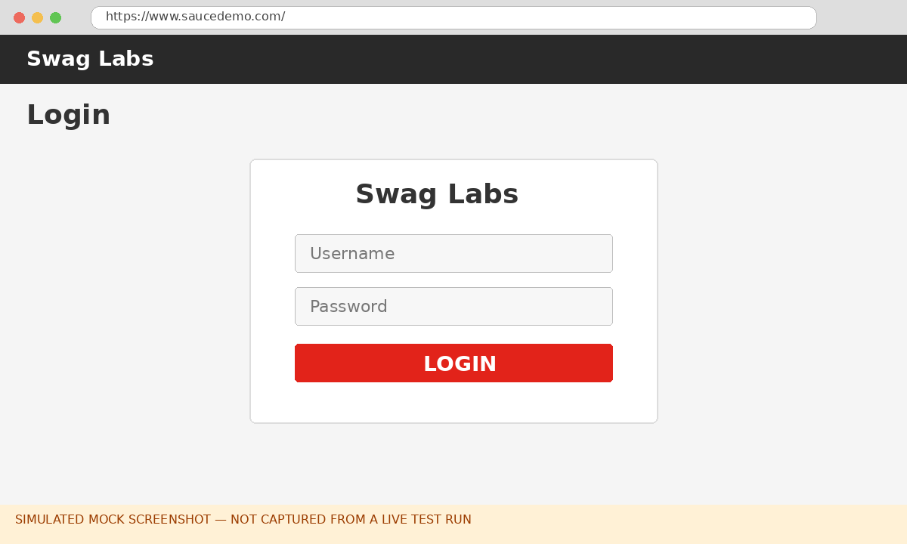
Illustrative mock image — not actual test evidence.

Mock 2 — Products page
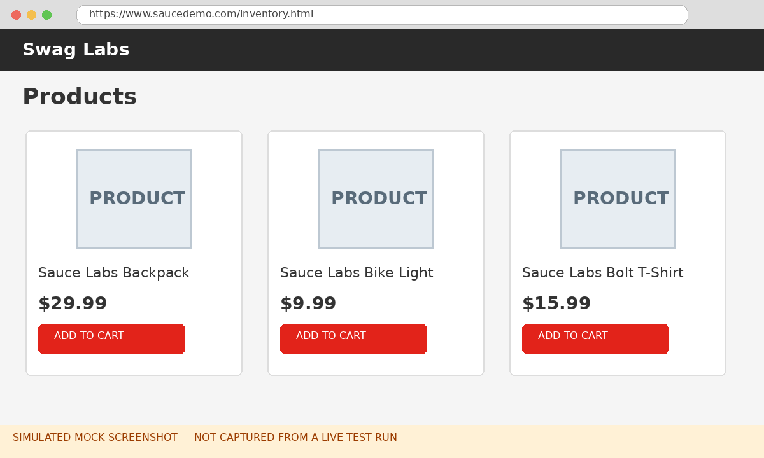
Illustrative mock image — not actual test evidence.

Mock 3 — Cart page
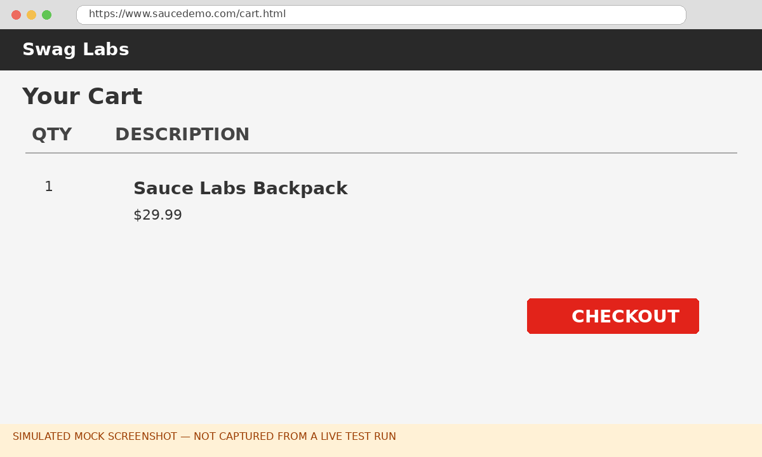

Mock 4 — Order confirmation
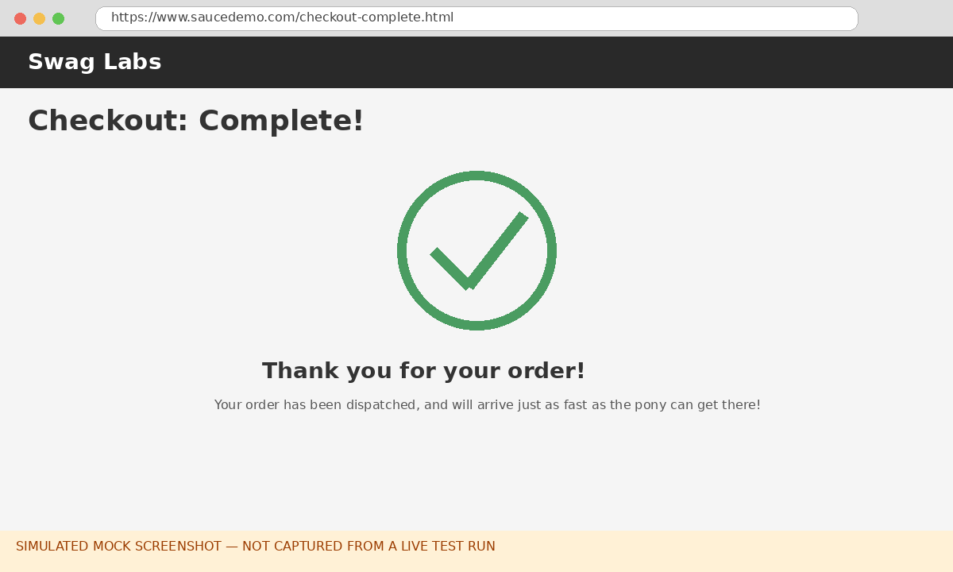

Appendix C: Complete Python Selenium Source Code
The following is the complete source code supplied with this report. It is intended to be executed in PyCharm after installing Selenium and ensuring Google Chrome is available. Actual test outcomes depend on running the script.
"""
Practical 11 - Python Automation Testing (Software Testing)
Application: SauceDemo - https://www.saucedemo.com/
Tools: Python, Selenium WebDriver, Google Chrome, PyCharm

Install:
pip install selenium

Run:
python tutorial11.py

This script tests website navigation, login validation, product selection,
links, cart, checkout workflow, browser back/forward, logout and regression.
It saves genuine screenshots in the "tutorial11_screenshots" folder.
"""
import os
import time
from datetime import datetime

from selenium import webdriver
from selenium.common.exceptions import TimeoutException, WebDriverException
from selenium.webdriver.common.by import By
from selenium.webdriver.support import expected_conditions as EC
from selenium.webdriver.support.ui import WebDriverWait

BASE_URL = "https://www.saucedemo.com/"
VALID_USER = "standard_user"
VALID_PASS = "secret_sauce"
INVALID_PASS = "wrong_password"
PRODUCT_NAME = "Sauce Labs Backpack"
SCREENSHOT_DIR = "tutorial11_screenshots"
os.makedirs(SCREENSHOT_DIR, exist_ok=True)

results = []

def snap(driver, name):
"""Save a real screenshot of the current browser page."""
path = os.path.join(SCREENSHOT_DIR, name + ".png")
driver.save_screenshot(path)
print(f" Screenshot: {path}")

def run_step(test_id, description, action):
try:
detail = action()
status = "PASS"
except Exception as exc:
status = "FAIL"
detail = f"{type(exc).__name__}: {str(exc).splitlines()[0]}"
results.append((test_id, description, status, detail))
print(f"[{test_id}] {description}: {status}")
if detail:
print(f" -> {detail}")
return status == "PASS"

def login(driver, wait, username, password):
wait.until(EC.visibility_of_element_located((By.ID, "user-name"))).clear()
driver.find_element(By.ID, "user-name").send_keys(username)
driver.find_element(By.ID, "password").clear()
driver.find_element(By.ID, "password").send_keys(password)
driver.find_element(By.ID, "login-button").click()

def main():
options = webdriver.ChromeOptions()
driver = webdriver.Chrome(options=options)
driver.maximize_window()
wait = WebDriverWait(driver, 10)
start = time.time()
print("=" * 68)
print("Practical 11 - Python Automation Testing (SauceDemo)")
print(f"Execution started: {datetime.now():%d-%m-%Y %H:%M:%S}")
print("=" * 68)

try:
print(f"Browser: {driver.capabilities.get('browserName')} "
f"{driver.capabilities.get('browserVersion')}")
print(f"Selenium: {__import__('selenium').__version__}")
print()

def open_site():
driver.get(BASE_URL)
wait.until(EC.visibility_of_element_located((By.ID, "login-button")))
assert "Swag Labs" in driver.title
snap(driver, "01_login_page")
return f"Title='{driver.title}', URL={driver.current_url}"
run_step("TC-11-01", "Open website and verify title", open_site)

def invalid_login():
driver.get(BASE_URL)
login(driver, wait, VALID_USER, INVALID_PASS)
error = wait.until(EC.visibility_of_element_located(
(By.CSS_SELECTOR, "[data-test='error']"))).text
assert "Username and password do not match" in error
snap(driver, "02_invalid_login")
return error
run_step("TC-11-02", "Invalid login validation", invalid_login)

def empty_login():
driver.get(BASE_URL)
driver.find_element(By.ID, "login-button").click()
error = wait.until(EC.visibility_of_element_located(
(By.CSS_SELECTOR, "[data-test='error']"))).text
assert "Username is required" in error
return error
run_step("TC-11-03", "Empty login form validation", empty_login)

def valid_login():
driver.get(BASE_URL)
login(driver, wait, VALID_USER, VALID_PASS)
wait.until(EC.url_contains("inventory"))
assert "inventory.html" in driver.current_url
assert driver.find_element(By.CLASS_NAME, "title").text == "Products"
snap(driver, "03_products_page")
return f"Products page opened: {driver.current_url}"
run_step("TC-11-04", "Valid login", valid_login)

def product_listing():
items = wait.until(EC.presence_of_all_elements_located(
(By.CLASS_NAME, "inventory_item")))
assert len(items) > 0
return f"{len(items)} products displayed"
run_step("TC-11-05", "Verify product listing", product_listing)

def about_link():
driver.find_element(By.ID, "react-burger-menu-btn").click()
about = wait.until(EC.visibility_of_element_located(
(By.ID, "about_sidebar_link")))
href = about.get_attribute("href")
assert "saucelabs.com" in href
driver.find_element(By.ID, "react-burger-cross-btn").click()
return f"About link destination: {href}"
run_step("TC-11-06", "Verify menu About link", about_link)

def add_product():
driver.find_element(By.ID, "add-to-cart-sauce-labs-backpack").click()
badge = wait.until(EC.visibility_of_element_located(
(By.CLASS_NAME, "shopping_cart_badge"))).text
assert badge == "1"
snap(driver, "04_product_added")
return f"{PRODUCT_NAME} added; cart badge={badge}"
run_step("TC-11-07", "Add product to cart", add_product)

def open_cart():
driver.find_element(By.CLASS_NAME, "shopping_cart_link").click()
wait.until(EC.url_contains("cart.html"))
item = wait.until(EC.visibility_of_element_located(
(By.CLASS_NAME, "inventory_item_name"))).text
assert item == PRODUCT_NAME
snap(driver, "05_cart_page")
return f"Cart contains: {item}"
run_step("TC-11-08", "Open cart and verify item", open_cart)

def continue_shopping():
driver.find_element(By.ID, "continue-shopping").click()
wait.until(EC.url_contains("inventory"))
assert "inventory.html" in driver.current_url
driver.find_element(By.CLASS_NAME, "shopping_cart_link").click()
wait.until(EC.url_contains("cart.html"))
return "Continue Shopping returned to Products page"
run_step("TC-11-09", "Continue Shopping link", continue_shopping)

def checkout_form():
driver.find_element(By.ID, "checkout").click()
wait.until(EC.visibility_of_element_located((By.ID, "first-name")))
snap(driver, "06_checkout_information")
driver.find_element(By.ID, "first-name").send_keys("Student")
driver.find_element(By.ID, "last-name").send_keys("Testing")
driver.find_element(By.ID, "postal-code").send_keys("380001")
driver.find_element(By.ID, "continue").click()
wait.until(EC.url_contains("checkout-step-two"))
snap(driver, "07_checkout_overview")
return f"Checkout information accepted: {driver.current_url}"
run_step("TC-11-10", "Checkout form and multi-page workflow", checkout_form)

def back_forward():
driver.back()
wait.until(EC.url_contains("checkout-step-one"))
assert "checkout-step-one" in driver.current_url
driver.forward()
wait.until(EC.url_contains("checkout-step-two"))
assert "checkout-step-two" in driver.current_url
return "Back -> checkout step one; Forward -> checkout step two"
run_step("TC-11-11", "Browser back/forward navigation", back_forward)

def overview():
item = wait.until(EC.visibility_of_element_located(
(By.CLASS_NAME, "inventory_item_name"))).text
assert item == PRODUCT_NAME
return f"Order overview contains {item}"
run_step("TC-11-12", "Verify order overview", overview)

def finish_order():
driver.find_element(By.ID, "finish").click()
wait.until(EC.url_contains("checkout-complete"))
msg = wait.until(EC.visibility_of_element_located(
(By.CLASS_NAME, "complete-header"))).text
assert "Thank you for your order" in msg
snap(driver, "08_order_confirmation")
return msg
run_step("TC-11-13", "Complete order", finish_order)

def logout():
driver.find_element(By.ID, "react-burger-menu-btn").click()
wait.until(EC.element_to_be_clickable((By.ID, "logout_sidebar_link"))).click()
wait.until(EC.visibility_of_element_located((By.ID, "login-button")))
assert driver.current_url == BASE_URL
return "Returned to login page"
run_step("TC-11-14", "Logout", logout)

def relogin_regression():
login(driver, wait, VALID_USER, VALID_PASS)
wait.until(EC.url_contains("inventory"))
items = wait.until(EC.presence_of_all_elements_located(
(By.CLASS_NAME, "inventory_item")))
assert len(items) > 0
return f"Re-login successful; {len(items)} products displayed"
run_step("TC-11-15", "Regression: re-login after logout", relogin_regression)

def cart_reset_regression():
button = wait.until(EC.visibility_of_element_located(
(By.ID, "add-to-cart-sauce-labs-backpack")))
assert button.text.lower() == "add to cart"
assert not driver.find_elements(By.CLASS_NAME, "shopping_cart_badge")
return "Cart is empty after order; product can be added again"
run_step("TC-11-16", "Regression: cart reset after order", cart_reset_regression)

def empty_checkout_validation():
driver.get(BASE_URL)
login(driver, wait, VALID_USER, VALID_PASS)
wait.until(EC.url_contains("inventory"))
driver.find_element(By.ID, "add-to-cart-sauce-labs-backpack").click()
driver.find_element(By.CLASS_NAME, "shopping_cart_link").click()
wait.until(EC.url_contains("cart.html"))
driver.find_element(By.ID, "checkout").click()
wait.until(EC.visibility_of_element_located((By.ID, "first-name")))
driver.find_element(By.ID, "continue").click()
error = wait.until(EC.visibility_of_element_located(
(By.CSS_SELECTOR, "[data-test='error']"))).text
assert "First Name is required" in error
snap(driver, "09_empty_checkout_validation")
return error
run_step("TC-11-17", "Validation: empty checkout form", empty_checkout_validation)

except WebDriverException as exc:
print(f"CRITICAL BROWSER ERROR: {exc}")
finally:
driver.quit()
elapsed = time.time() - start
passed = sum(1 for row in results if row[2] == "PASS")
failed = len(results) - passed
print("\n" + "=" * 68)
print("EXECUTION SUMMARY")
print("=" * 68)
for test_id, desc, status, _ in results:
print(f"{test_id:<12} {desc:<43} {status}")
print("-" * 68)
print(f"Total test steps : {len(results)}")
print(f"Passed : {passed}")
print(f"Failed : {failed}")
print(f"Execution time : {elapsed:.2f} seconds")
print(f"Overall status : {'PASS' if failed == 0 and len(results) == 17 else 'FAIL'}")
print(f"Screenshots saved in: {SCREENSHOT_DIR}")
print("=" * 68)

if __name__ == "__main__":
main()

